/*--------------------------------------------------------------------------------------------------------------

CREATE A DATABASE CALLED country THAT HAS ONE TABLE WITH THE FOLLOWING FIELDS:

name of country (primary key)

population

primary language

USE THE WEB TO OBTAIN INFORMATION and POPULATE THE TABLE WITH AT LEAST 8 LINES OF DATA.

RUN THE FOLLOWING QUERIES ON YOUR DATABASE:

1. List the entire table

2. List of all countries with populations sorted by population in descending order

3. List country with the smallest population (Read up on the LIMIT keyword in MySQL http://www.mysqltutorial.org/mysql-limit.aspx)

4. List all countries that have a primary language of FRENCH

------------------------------------------------------------------------------------------------------------------*/

mysql> create dataset mohamed_country;

mysql> use mohamed_country;

name of country (primary key)

population

primary language

mysql> create table country_MO (name varcher(100), popultion Bigint, primary language(100));

mysql> inset into country_MO (name, population, primary_language) values (“Egypt”, 100000000, “Arabic”);

mysql> inset into country_MO (name, population, primary_language) values (“Bangladesh”, 200000000, “Bangle”);

mysql> inset into country_MO (name, population, primary_language) values (“India”, 121022, “Bangle”);

mysql> inset into country_MO (name, population, primary_language) values (“USA”, 308000000, “English”);

mysql> inset into country_MO (name, population, primary_language) values (“China”, 13410000000, “mandarin”);

mysql> inset into country_MO (name, population, primary_language) values (“France”, 64720690, “Franch”);

mysql> inset into country_MO (name, population, primary_language) values (“Turkey”, 79512429, “Turkish”);

mysql> inset into country_MO (name, population, primary_language) values (“Mexico”, 127540423, “Spanish”);

/* USE THE WEB TO OBTAIN INFORMATION and POPULATE THE TABLE WITH AT LEAST 8 LINES OF DATA.

RUN THE FOLLOWING QUERIES ON YOUR DATABASE:

1. List the entire table*/

mysql> select * form country_MO;

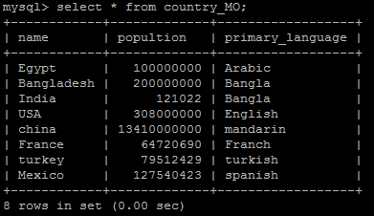

/* 2. List of all countries with populations sorted by population in descending order*/

mysql> select name, populition from country_MO order by popultion;

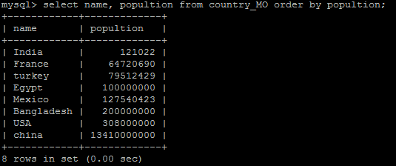

/* 3. List country with the smallest population*/

mysql> select name, populition from country_MO order by popultion desc;

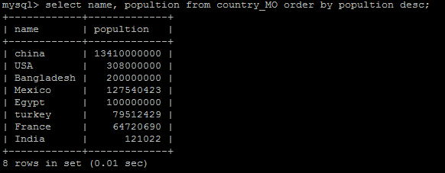

/*4. List all countries that have a primary language of FRENCH*/

Mysql> select name from country_MO where primary_languange = ’Franch’;

